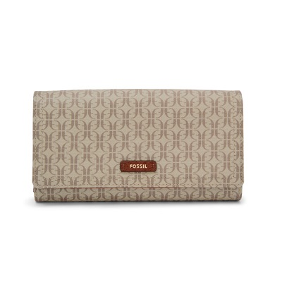

Logan RFID Flap Clutch

PRODUCT DETAILS

**Silhouette: Flap Clutch**

**Exterior Material: 100% PVC/Polyurethane Trim**

**Interior Details: 1 ID Window, 1 Zipper Pocket, 2 Bill Compartments, 2 Gusseted Pockets, 12 Credit Card Slots**

**Measurements: 7.63"L x 1"W x 4"H**

**Warranty: 1 Year Limited**